EXPERIMENT-7
7. A chess-playing AI must determine the best move against an opponent. Implement the Minimax Algorithm. Select the optimal move through adversarial search.

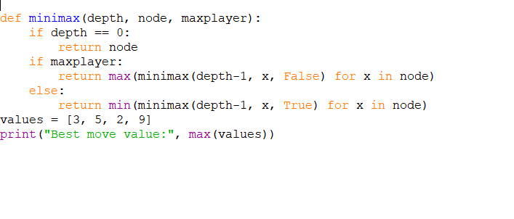
PROGRAM:

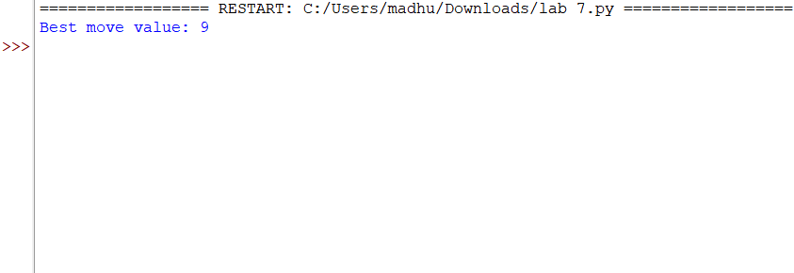
OUTPUT:

